**PIZZA SALES SQL QUERIES**

**A. KPI’s**

**1. Total Revenue**

SELECT SUM(TOTAL_PRICE) AS TOTAL_REVENUE FROM PIZZA_SALES;

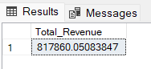

**2. Average Order Value**

SELECT (SUM(TOTAL_PRICE) / COUNT(DISTINCT ORDER_ID)) AS AVG_ORDER_VALUE FROM PIZZA_SALES;

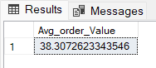

**3. Total Pizzas Sold**

SELECT SUM(QUANTITY) AS TOTAL_PIZZA_SOLD FROM PIZZA_SALES;

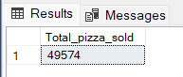

**4. Total Orders**

SELECT COUNT(DISTINCT ORDER_ID) AS TOTAL_ORDERS FROM PIZZA_SALES;

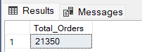

**5. Average Pizzas Per Order**

SELECT CAST(CAST(SUM(QUANTITY) AS DECIMAL(10,2)) /

           CAST(COUNT(DISTINCT ORDER_ID) AS DECIMAL(10,2)) AS DECIMAL(10,2)) AS AVG_PIZZAS_PER_ORDER

FROM PIZZA_SALES;

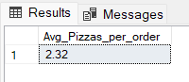

**B. Daily Trend for Total Orders**

SELECT DAYNAME(STR_TO_DATE(ORDER_DATE,'%D-%M-%Y')) AS DAY_ORDER,

       COUNT(DISTINCT(ORDER_ID)) AS TOTAL_ORDERS

FROM PIZZA_SALES

GROUP BY DAYNAME(STR_TO_DATE(ORDER_DATE,'%D-%M-%Y'));

***Output:***

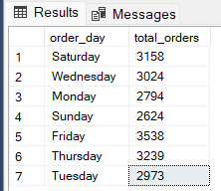

**C. Hourly Trend for Orders**

SELECT HOUR(ORDER_TIME) AS ORDER_HOURS,

       COUNT(DISTINCT ORDER_ID) AS TOTAL_ORDERS

FROM PIZZA_SALES

GROUP BY HOUR(ORDER_TIME)

ORDER BY HOUR(ORDER_TIME);

***Output***

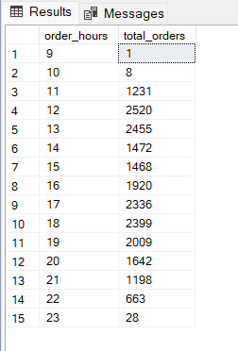

**D. % of Sales by Pizza Category**

SELECT PIZZA_CATEGORY,

       CAST(SUM(TOTAL_PRICE) AS DECIMAL(10,2)) AS TOTAL_REVENUE,

       CAST(SUM(TOTAL_PRICE) * 100 / (SELECT SUM(TOTAL_PRICE) FROM PIZZA_SALES) AS DECIMAL(10,2)) AS PCT

FROM PIZZA_SALES

GROUP BY PIZZA_CATEGORY;

***Output***

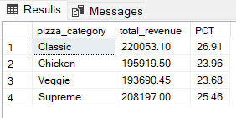

**E. % of Sales by Pizza Size**

SELECT PIZZA_SIZE,

       CAST(SUM(TOTAL_PRICE) AS DECIMAL(10,2)) AS TOTAL_REVENUE,

       CAST(SUM(TOTAL_PRICE) * 100 / (SELECT SUM(TOTAL_PRICE) FROM PIZZA_SALES) AS DECIMAL(10,2)) AS PCT

FROM PIZZA_SALES

GROUP BY PIZZA_SIZE

ORDER BY PIZZA_SIZE;

***Output***

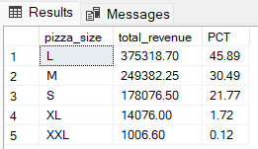

**F. Total Pizzas Sold by Pizza Category**

SELECT PIZZA_CATEGORY, SUM(QUANTITY) AS TOTAL_QUANTITY_SOLD

FROM PIZZA_SALES

GROUP BY PIZZA_CATEGORY

ORDER BY TOTAL_QUANTITY_SOLD DESC;

***Output***

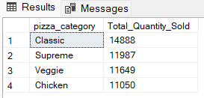

**G. Top 5 Best Sellers by Total Pizzas Sold**

SELECT PIZZA_NAME, SUM(QUANTITY) AS TOTAL_QUANTITY

FROM PIZZA_SALES

GROUP BY PIZZA_NAME

ORDER BY TOTAL_QUANTITY DESC

LIMIT 5;

***Output***

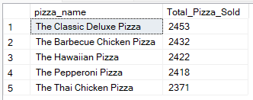

**H. Bottom 5 Best Sellers by Total Pizzas Sold**

SELECT PIZZA_NAME, SUM(QUANTITY) AS TOTAL_QUANTITY

FROM PIZZA_SALES

GROUP BY PIZZA_NAME

ORDER BY TOTAL_QUANTITY

LIMIT 5;

***Output***

